31/05/19
THM 348 Service Operations Management
Final Exam Answer Sheet
- In his effort to improve the quality of its hotel, James Carry, the general manager of a prestigious 5-star hotel located in Liverpool, analyzed various “Complaint Cards” filled by customers for the last 12 weeks. The following problematic areas along with their frequencies were observed:
- Prepare a Pareto Chart for the above data. (2 Points)
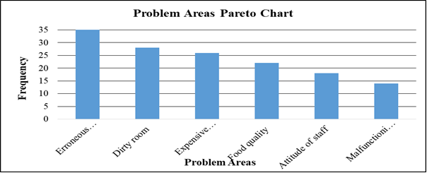
- As “Erroneous billing” problem had the highest frequency amongst the other problems, James Carry decided to tackle it first. He made several brainstorming meetings with Rooms Division manager as well as Accounting manager at the end of which they decided there is a need to re-train the departments’ staff. For the upcoming month, the hotel conducted related training sessions. After a while, the general manager wanted to see if there are any quality improvements in the process. For that, he decided to use run chart. He prepared the following table depicting weekly customer complaints (before / after re-training). The following table reveals the following results:
Prepare a run chart to compare customer complaints before and after re-training departments’ staff. (2 Points)
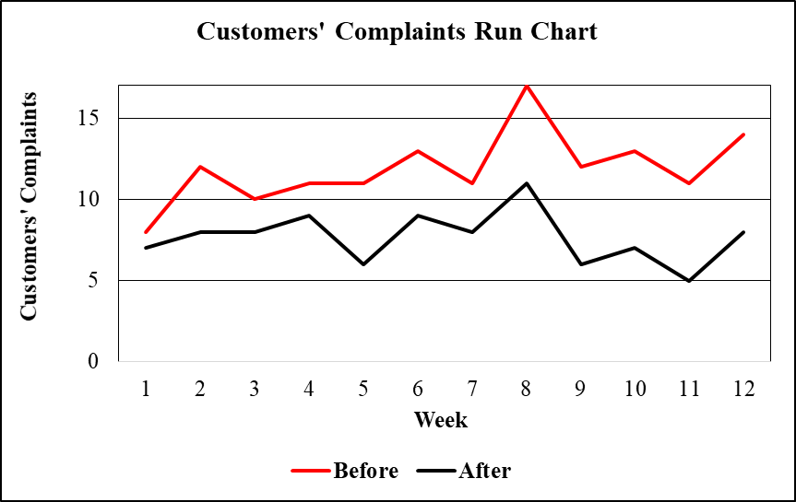
c) Analyze the finding in part b). Is there any improvement as far as customers’ complaints are concerned after re-training departments’ staff? If there is an improvement, what is the next problem that James Carry shall try and solve? Explain the reason behind your answer. (1 Point)
As seen from the run chart prepared in part b), there is a clear improvement as far as customers’ complaints are concerned after re-training departments’ staff. The next problem that James Carry shall try and solve is “Dirty room” because the frequency associated with this very problematic area is the highest after “Erroneous billing” problem.
- What is “Omnichannel Supply Chain”? What are the benefits of this very chain? (2 Points)
Omnichannel supply chain is a chain that uses a central stock pool to manage the fulfillment operation in a supply chain consisting of various ordering options and multiple distribution channels. The benefits of this very channel are as follows:
- Increase the visibility of warehouse inventory regardless of chain.
- Allow for higher service levels at lower cost.
- Allow customers to check their order status.
- Contrast “Cognitive Knowledge” to “Systems Understanding Knowledge”? (2 Points)
While cognitive knowledge (know-what) refers to the basic mastery of a discipline achieved through extensive training and certification, systems understanding knowledge (know-why) refers to deep knowledge of the web of cause-and-effect relationships underlying the discipline.
- What are the advantages (2 Points) and disadvantages (1 Point) of “Focused Network” over “Focused Service”?
Some advantages of focused network over focused service are as follows:
- More accessibility to customers.
- Achieve significant growth.
- Prevent concept imitation from competitors.
- Reduces firm’s financial risk from severe, localized economic downturns.
Some disadvantages of focused network over focused service are as follows:
- Possibility of losing control over the whole operations.
- Possibility of output inconsistency → quality problems.
- Risk of overexpansion.
- Under what conditions “Transnational Strategy” can be adopted? Provide one example of a company using this very strategy. (2 Points)
Transnational strategy can be adopted when there are benefits from leveraging certain corporate assets such as research and specialized expertise but the service delivery must be adapted to local needs.
An example of a company using this strategy is Toys”R”Us.
- During the past season, Ljajiç Resort Hotel did not achieve very high occupancy rates despite a reservation system that was designed to keep the hotel fully booked. Apparently, prospective guests were making reservations that, for one reason or another, they failed to honor. A review of Front-desk records during the current peak period, when the Resort Hotel was fully booked, revealed the record of no-shows as shown in the below table:
No-shows | Probability | Reservations Overbooked | Cumulative Probability
0 | 0.08 | 0 | 0.00
1 | 0.09 | 1 | 0.08
2 | 0.10 | 2 | 0.17
3 | 0.12 | 3 | 0.27
4 | 0.14 | 4 | 0.39
5 | 0.17 | 5 | 0.53
6 | 0.10 | 6 | 0.70
7 | 0.08 | 7 | 0.80
8 | 0.07 | 8 | 0.88
9 | 0.04 | 9 | 0.95
10 | 0.01 | 10 | 0.99
Suppose that a vacant room (because of No Show) results in an opportunity loss of $ 70.
- Calculate the Expected Number of No Show Rooms. (2 Points)
- Expected number of no show rooms = (0.08 * 0) + (0.09 * 1) + (0.10 * 2) + (0.12 * 3) + (0.14 * 4) + (0.17 * 5) + (0.10 * 6) + (0.08 * 7) + (0.07 * 8) + (0.04 * 9) + (0.01 * 10) = 0 + 0.09 + 0.20 + 0.36 + 0.56 + 0.85 + 0.60 + 0.56 + + 0.56 + 0.36 + 0.10 = 4.24 rooms.
- Calculate the Expected Opportunity Loss. (1 Point)
- Expected Opportunity Loss = 4.24 * 70 = $ 296.80.
In order to avoid some of this loss, Ljajiç Resort Hotel management is considering an overbooking policy. Yet, if a guest holding a reservation is turned away (due to overbooking), other costs would be incurred. Ljajiç Resort Hotel has made arrangements with a nearby Resort Hotel (Seba Resort Hotel) to pay for the rooms of guests whom it cannot accommodate. Further, a penalty is associated with the loss of customer goodwill and the impact this has on future business. Management estimates this total loss to be approximately $ 125 per turned out guest.
- Fill the below Overbooking Loss Table (4 Points)
 |  | Reservations Overbooked
No-shows | Prob. | 0 | 1 | 2 | 3 | 4 | 5 | 6 | 7 | 8 | 9 | 10
0 | 0.08 | $0 | $125 | $250 | $375 | $500 | $625 | $750 | $875 | $1,000 | $1,125 | $1,250
1 | 0.09 | $70 | $0 | $125 | $250 | $375 | $500 | $625 | $750 | $875 | $1,000 | $1,125
2 | 0.10 | $140 | $70 | $0 | $125 | $250 | $375 | $500 | $625 | $750 | $875 | $1,000
3 | 0.12 | $210 | $140 | $70 | $0 | $125 | $250 | $375 | $500 | $625 | $750 | $875
4 | 0.14 | $280 | $210 | $140 | $70 | $0 | $125 | $250 | $375 | $500 | $625 | $750
5 | 0.17 | $350 | $280 | $210 | $140 | $70 | $0 | $125 | $250 | $375 | $500 | $625
6 | 0.10 | $420 | $350 | $280 | $210 | $140 | $70 | $0 | $125 | $250 | $375 | $500
7 | 0.08 | $490 | $420 | $350 | $280 | $210 | $140 | $70 | $0 | $125 | $250 | $375
8 | 0.07 | $560 | $490 | $420 | $350 | $280 | $210 | $140 | $70 | $0 | $125 | $250
9 | 0.04 | $630 | $560 | $490 | $420 | $350 | $280 | $210 | $140 | $70 | $0 | $125
10 | 0.01 | $700 | $630 | $560 | $490 | $420 | $350 | $280 | $210 | $140 | $70 | $0
Expected | ------- | 296.80 | 242.40 | 205.55 | 188.20 | 194.25 | 227.60 | 294.10 | 380.10 | 481.70 | 596.95 | 720.00
Loss ($)
- How many rooms shall be overbooked? Why? (2 Points)
According to the above overbooking loss table, 3 rooms shall be overbooked, since, this very scenario yields the least expected loss.
N.B: Your answers to parts a), b) c) & d) shall be rounded to the nearest cent.
- Briefly explain how creating adjustable capacity chases demand. Provide 1 example clarifying this point. (2 Points)
A portion of capacity can be made variable through design. This way companies could adjust their capacities to various demand from various market segments. To clarify, airline companies routinely more the partition between first class and coach to meet the changing mix of passengers.
Good Luck

